**Challenge1 – Reference type**

**Index.html**

<!DOCTYPE html>

<html lang="en">

<head>

    <meta charset="UTF-8">

    <meta http-equiv="X-UA-Compatible" content="IE=edge">

    <meta name="viewport" content="width=device-width, initial-scale=1.0">

    <title>Types and variables</title>

</head>

<body>

    <script src="./index.js"></script>

</body>

</html>

**Index.js**

console.log({name:"Indrasenareddy", age:22, city: "Guntur"})

**result**

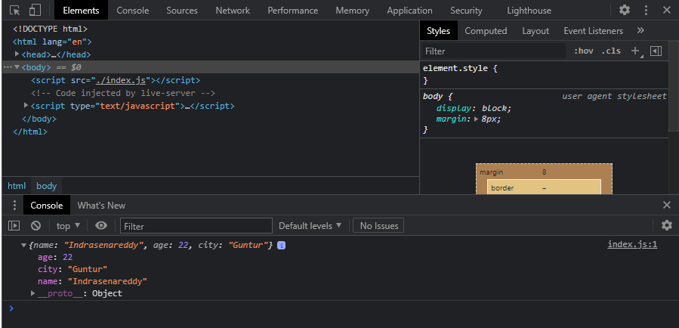

**Challenge2- Variable Declaration and Assignment**

**Index.html**

<!DOCTYPE html>

<html lang="en">

<head>

    <meta charset="UTF-8">

    <meta http-equiv="X-UA-Compatible" content="IE=edge">

    <meta name="viewport" content="width=device-width, initial-scale=1.0">

    <title>Types and variables</title>

</head>

<body>

    <script src="Challenge1.js"></script>

</body>

</html>

**Challenge1.js**

const myObject={};

console.log(myObject);

**Result** 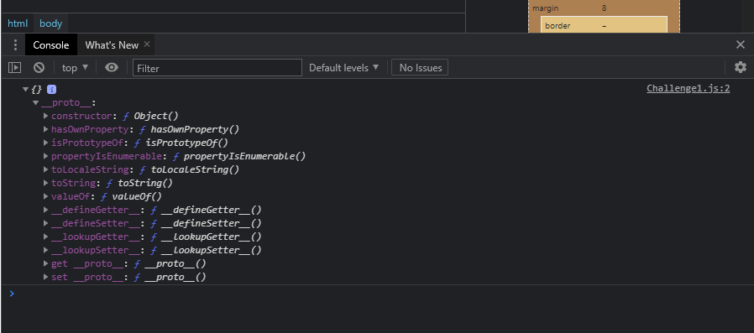

**Challenge 3- variables reusage**

**Index.html**

<!DOCTYPE html>

<html lang="en">

<head>

    <meta charset="UTF-8">

    <meta http-equiv="X-UA-Compatible" content="IE=edge">

    <meta name="viewport" content="width=device-width, initial-scale=1.0">

    <title>Types and variables</title>

</head>

<body>

    <script src="challenge2.js"></script>

</body>

</html>

**Challenge2.js**

var x=10;

var y=true;

var myObject={

    a:x,

    b:y

}

console.log(myObject);

let anotherObject={

    newA: 20,

    b:y,

    c:myObject

}

console.log(anotherObject);

**Result**

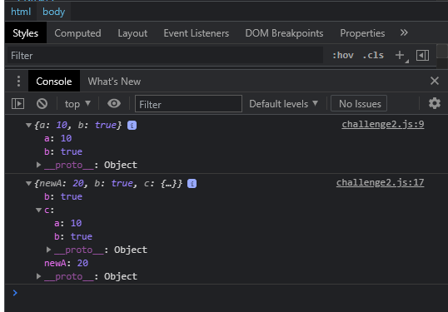

**Challenge4- typeof variables**

**Index.html**

<!DOCTYPE html>

<html lang="en">

<head>

    <meta charset="UTF-8">

    <meta http-equiv="X-UA-Compatible" content="IE=edge">

    <meta name="viewport" content="width=device-width, initial-scale=1.0">

    <title>Types and variables</title>

</head>

<body>

    <script src="challenge3.js"></script>

</body>

</html>

**Challenge3.js**

var a;

a=null;

console.log(typeof(a));

a=10;

console.log(typeof(a));

a=false;

console.log(typeof(a));

**Result**

